CASPER Untargeted Metabolomics

Tim Vigers & Laura Pyle

04 November 2020

# Preprocessing

Removed 0 samples missing > 80% of compounds and 0 samples with > 80% of compounds equal to 0.

# PCA

# PLS-DA

## PLS-DA Performance

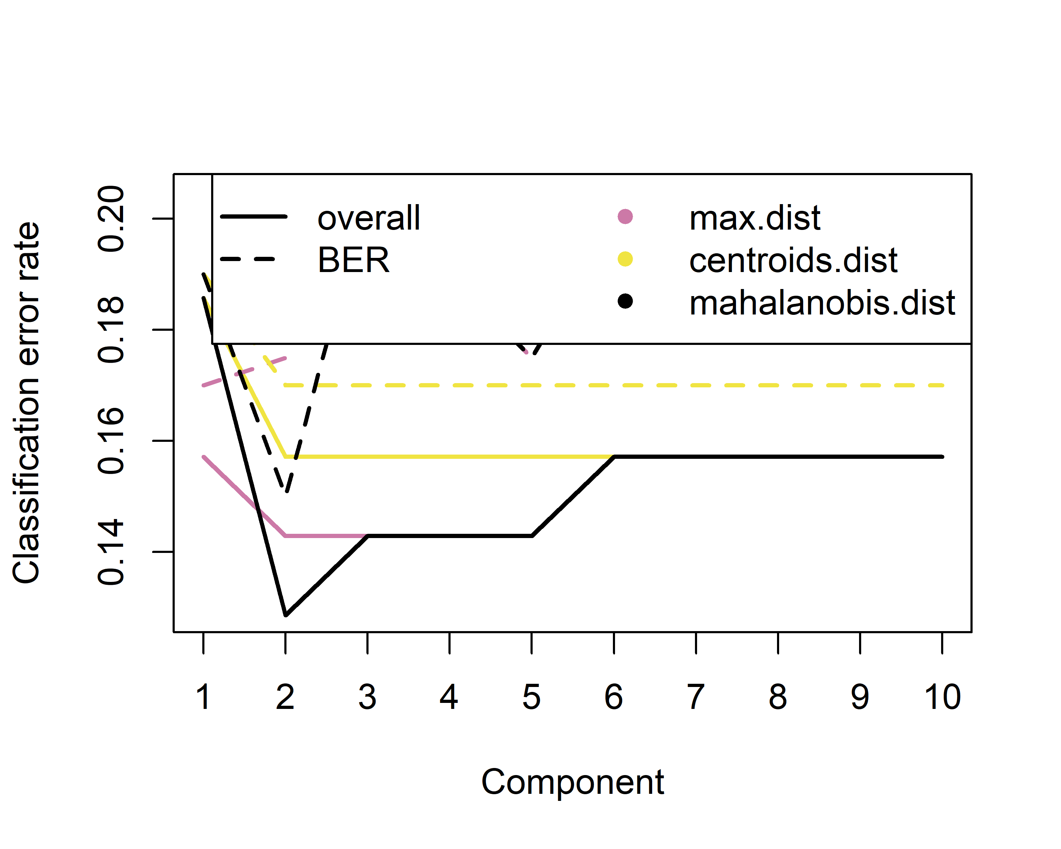

Performance was evaluated for 10 PLS-DA components using leave one out (LOO) cross-validation (CV). Two components resulted in the lowest overall classification error. For component 1, overall error rate was 0.186 with AUC of 0.935. For component 2, overall error rate was 0.157 with AUC of 0.95.

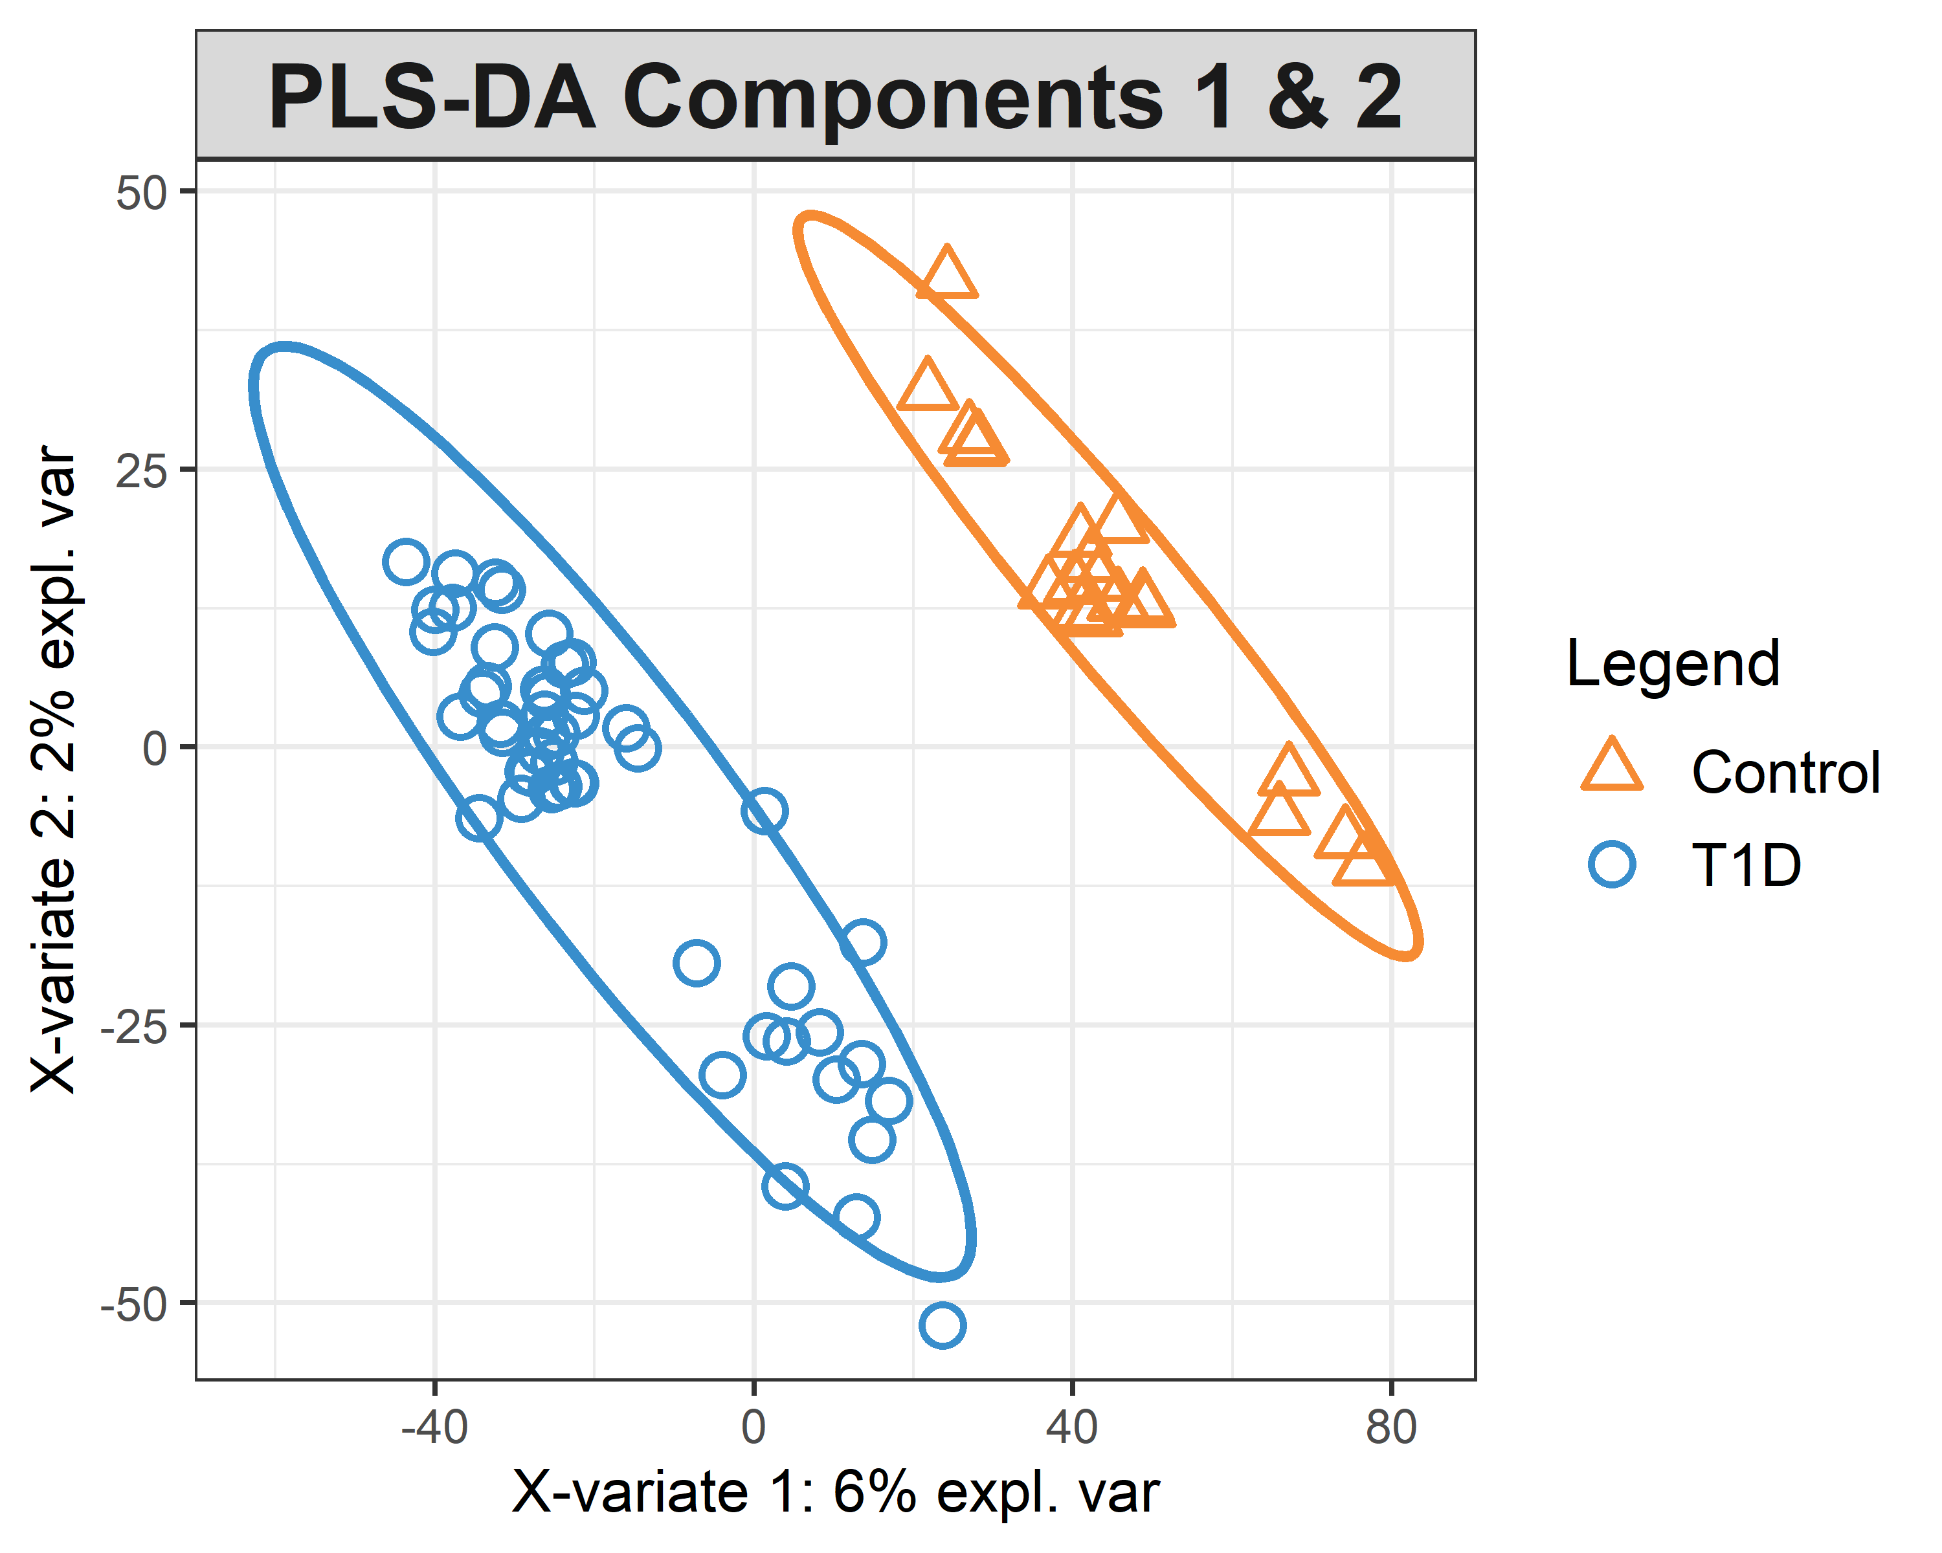

## Permutation Testing

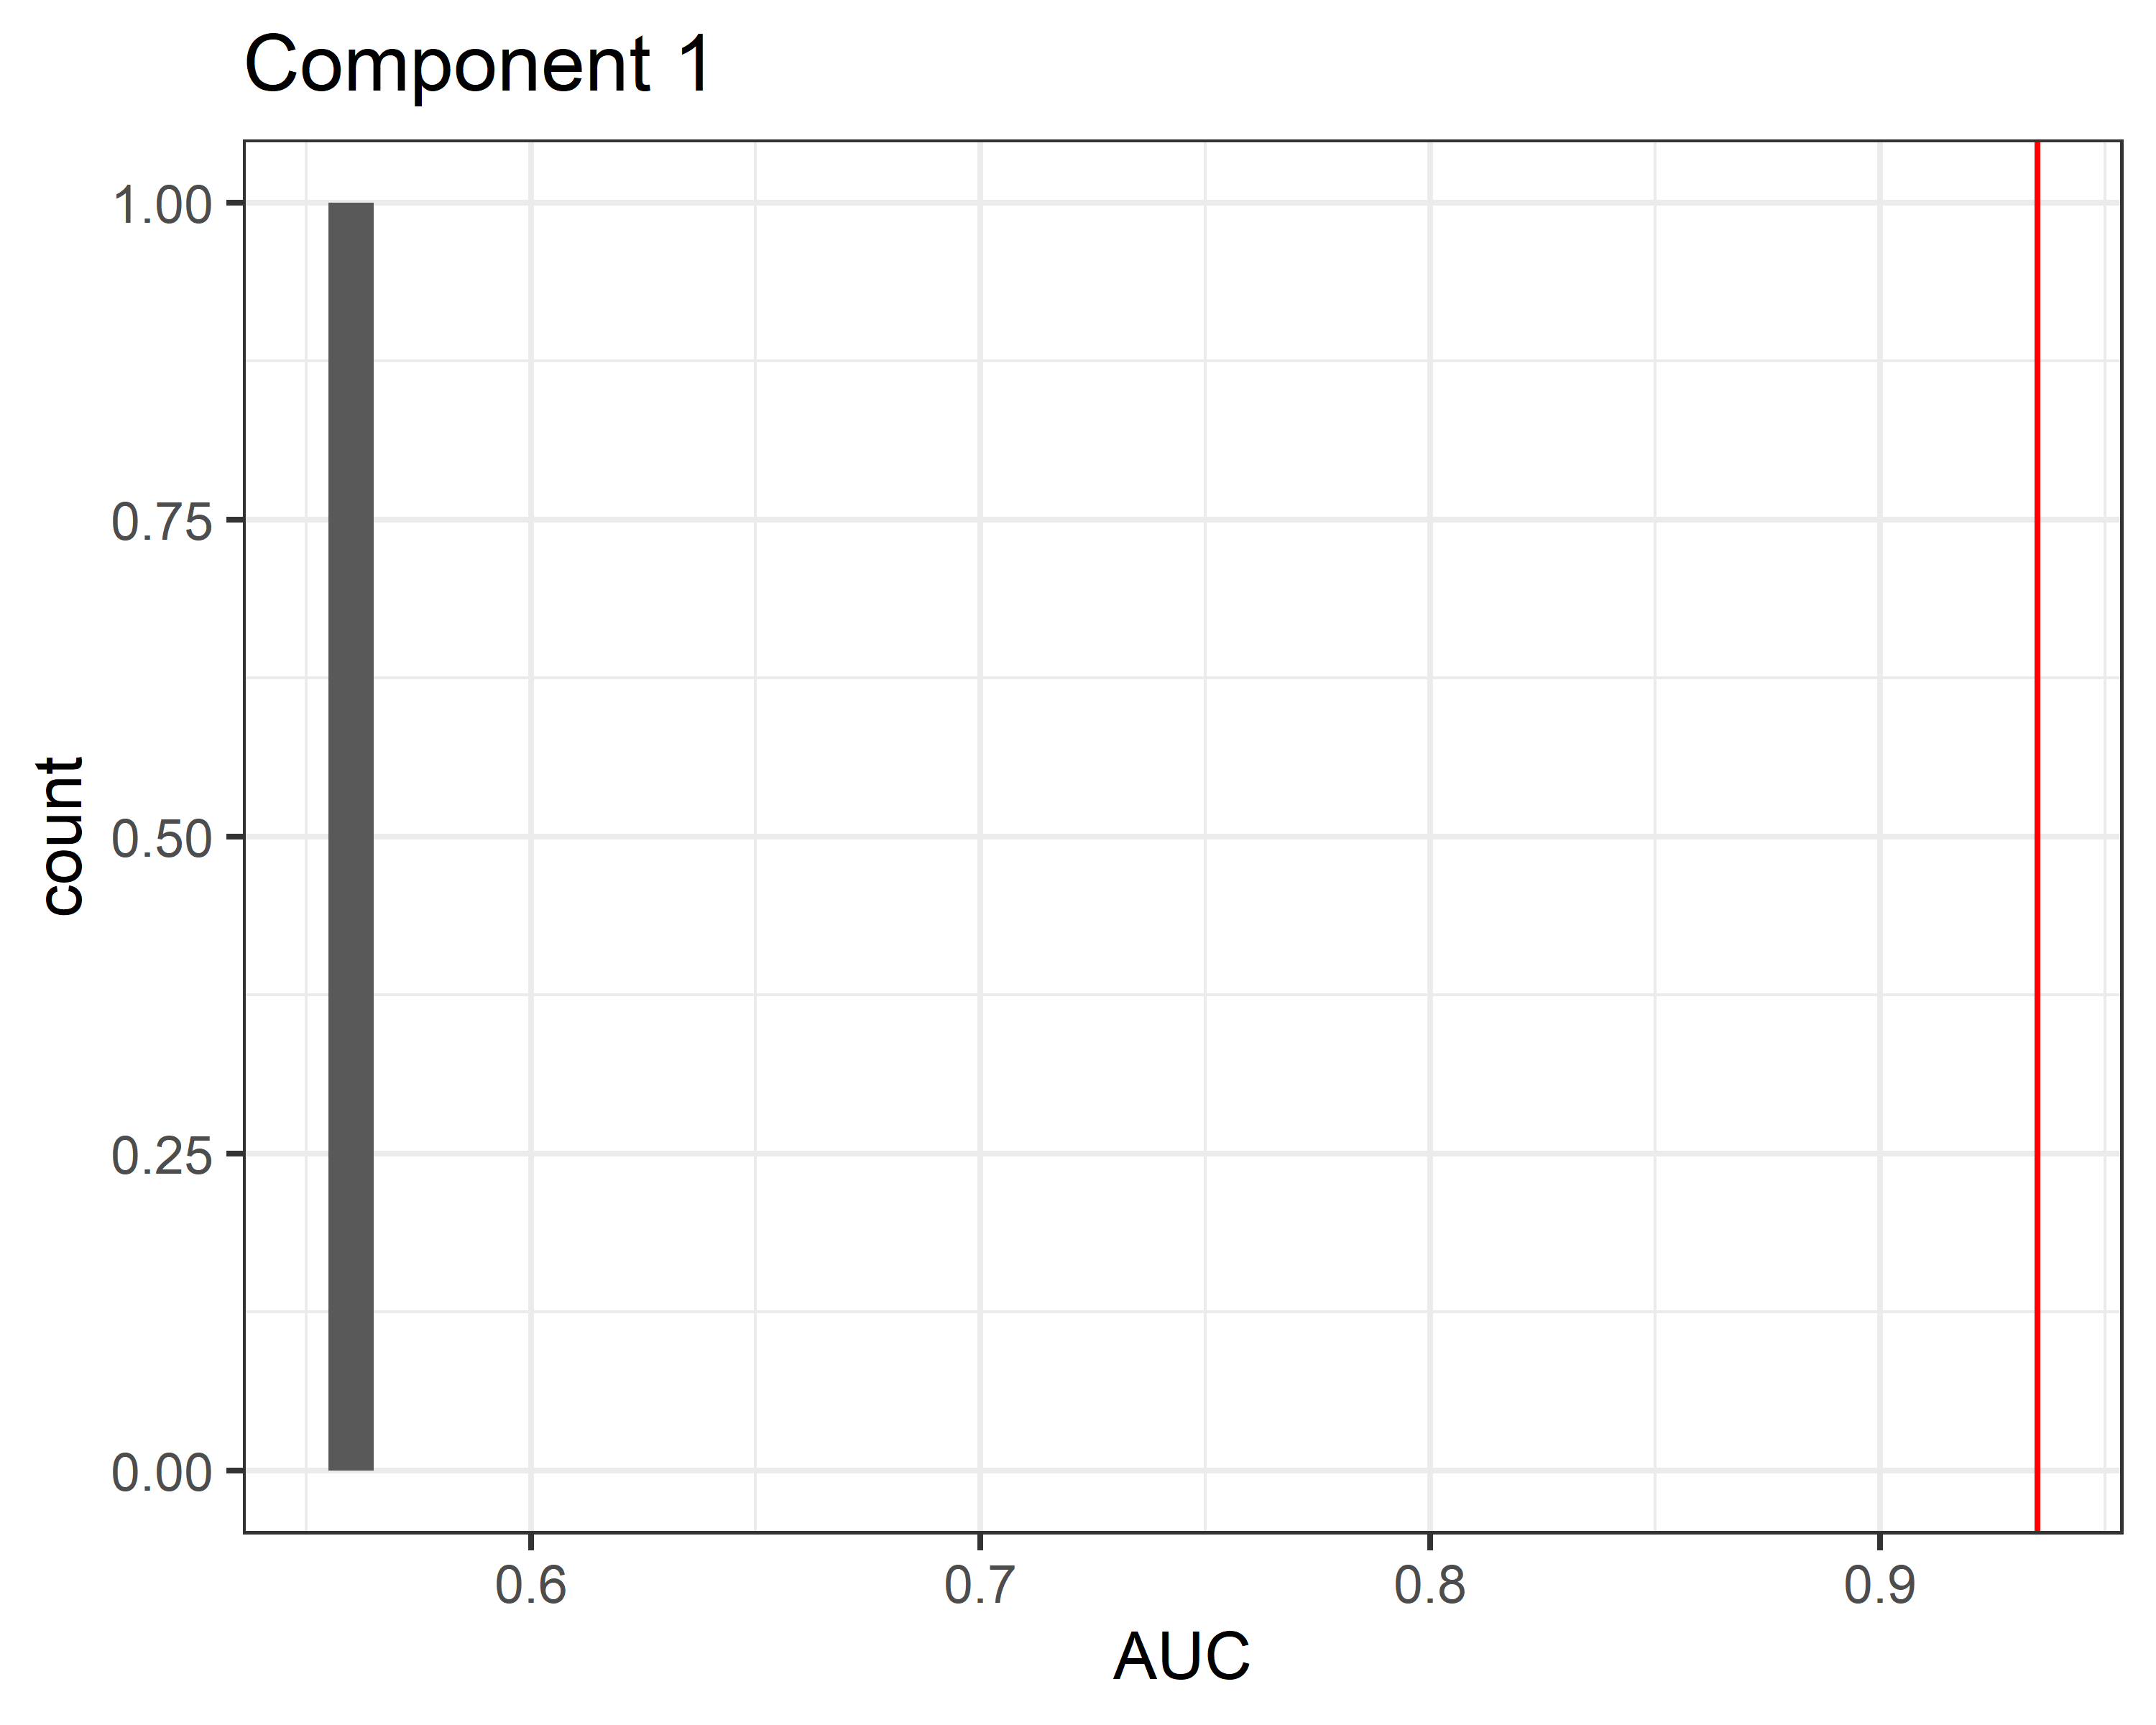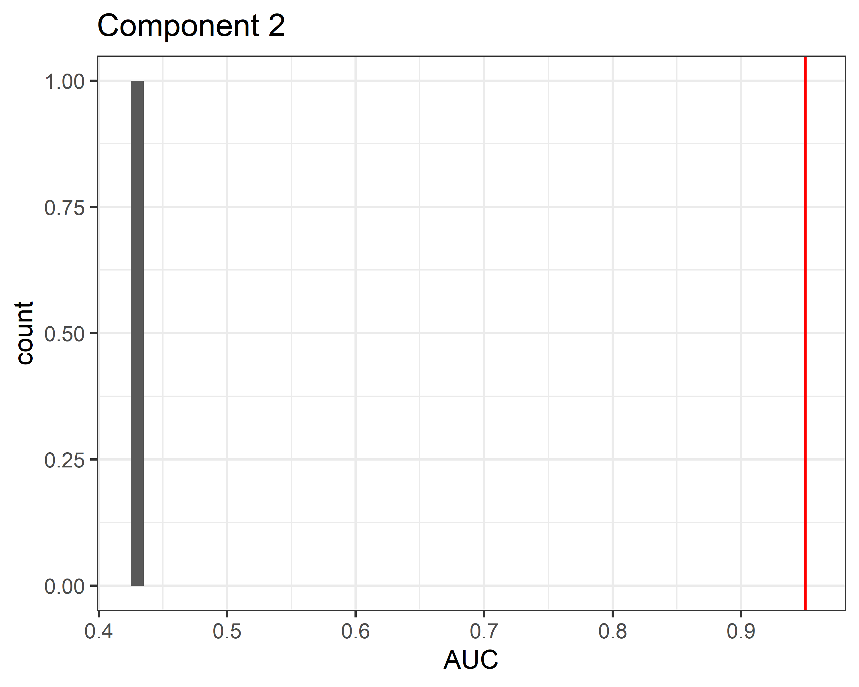

Group labels were permuted 1 times. Two component PLS-DA was run for each permutation and AUC was calculated using LOO CV. Red line indicates the AUC calculated for non-permuted data, and the gray histogram represents the null distribution of AUC. So, the permutation-based p value for AUC of component 1 is 0.5 and is 0.5 for component 2. In other words, it’s likely that PLS-DA is finding genuine differences between group 1 and group 4 and the AUC is not purely due to overfitting.

## Loadings

List of top 20 identified compounds in terms of discrimination for component 1 of the PLS-DA:

|  |
| --- |
| Compound Name |
| 2-Deoxyhexopyranose |
| N-(3-Chloropropyl)-1-methyl-4-nitro-1H-imidazol-5-amine |
| Heptose |
| Heptose |
| Glutaric acid |
| DMH |
| Malondialdehyde |
| Bis(4-cyanophenyl)methanol |
| Hexose |
| 2-Deoxyhexopyranose |
| 2,3,4,5,6,7,8-Heptahydroxyoctanal |
| bilirubin |
| 920863 |
| leucoline |
| 5385682 |
| debrisoquine |
| Tirapazamine |
| 1-(4-hydroxyquinazolin-2-yl)guanidine |
| Oxalic acid |
| Hexose |

List of top 20 identified compounds in terms of discrimination for component 2:

|  |
| --- |
| Compound Name |
| Tetrahydroisoquinoline-3-carboxylic acid |
| Glutaric anhydride |
| Aminolevulinic acid |
| Mesalazine |
| alpha-D-Galactopyranuronosyl-(1->4)-alpha-D-galactopyranuronosyl-(1->4)-D-galactopyranuronic acid |
| Cholesta-2,4-diene |
| 3748 |
| Methyl (6-hexadecyl-6-methoxy-3,6-dihydro-1,2-dioxin-3-yl)acetate |
| 3,5-Dimethylisoxazole-4-carboxylic acid |
| UW7525000 |
| 4-Morpholinylacetic acid |
| dimethyl itaconate |
| 3,5-Dimethylpyrazole |
| 2-(4,6-Diamino-1H-pyrazolo[3,4-d]pyrimidin-1-yl)ethanol |
| Diethylpyrocarbonate |
| L-(+)-Valine |
| Butyl isothiocyanate |
| Hexadecyl N-octanoylalaninate |
| Ethosuximide |
| Cholesta-2,4-diene |

# Moderated t tests

Top 20 identified metabolites that are significantly different between groups. P values adjusted using the FDR method. The reference group here is group 1, so negative logFC values indicate that the metabolite was lower in group 4 (and positive values indicate it was higher).

## Warning: Partial NA coefficients for 2 probe(s)

|  |  |  |  |  |  |
| --- | --- | --- | --- | --- | --- |
| Compound | m.z | logFC | t.score | p.value | adj.P.Val |
| 2-Deoxyhexopyranose | 164.06781 | 3.0670670 | 10.739000 | 0e+00 | 0.00e+00 |
| Heptose | 210.0733 | 2.5613641 | 8.869854 | 0e+00 | 0.00e+00 |
| N-(3-Chloropropyl)-1-methyl-4-nitro-1H-imidazol-5-amine | 218.05484 | 3.4944721 | 8.118144 | 0e+00 | 0.00e+00 |
| Glutaric acid | 132.0409 | -0.9412786 | -7.703776 | 0e+00 | 1.00e-07 |
| Tirapazamine | 178.04699 | -0.9014634 | -7.107664 | 0e+00 | 5.00e-07 |
| 2-Deoxyhexopyranose | 164.06855 | 0.7769967 | 7.046074 | 0e+00 | 6.00e-07 |
| Malondialdehyde | 72.01995 | -0.8538532 | -7.034824 | 0e+00 | 6.00e-07 |
| Hexose | 180.0627 | -0.7716885 | -6.837205 | 0e+00 | 1.30e-06 |
| Bis(4-cyanophenyl)methanol | 234.08169 | -1.7894569 | -6.624063 | 0e+00 | 2.60e-06 |
| 2-Oxobutyric acid | 102.03023 | -1.9170358 | -6.619421 | 0e+00 | 2.60e-06 |
| 920863 | 292.13164 | 1.5369409 | 6.606615 | 0e+00 | 2.70e-06 |
| bilirubin | 584.26337 | 1.7150637 | 6.323201 | 0e+00 | 6.80e-06 |
| 2-phosphinomethylmalic acid | 212.00811 | -1.2049781 | -6.240100 | 0e+00 | 8.80e-06 |
| Furazan-3,4-diamine, N,N’-dimethyl-N,N’-dinitro- | 218.04007 | 0.8474193 | 6.175526 | 0e+00 | 1.13e-05 |
| benzoquinone | 108.01971 | -0.7589072 | -6.076068 | 1e-07 | 1.53e-05 |
| Creatinine | 113.05938 | 1.6280474 | 6.043776 | 1e-07 | 1.68e-05 |
| Hexose | 180.06231 | -1.6761195 | -6.020627 | 1e-07 | 1.79e-05 |
| DMH | 150.05206 | 1.1468746 | 5.990389 | 1e-07 | 1.98e-05 |
| 2,7-Diiodo-9-fluorenone | 431.84988 | -1.3034100 | -5.940800 | 1e-07 | 2.33e-05 |
| Diethylpyrocarbonate | 162.05171 | -2.1569614 | -5.933479 | 1e-07 | 2.37e-05 |

# Heatmap



# Correlations for the Metabolites by Moderated t test

### Correlations

Table continues below

|  |  |
| --- | --- |
|  | M_I_kg_GC |
| **2-Deoxyhexopyranose** | 0.02848 |
| **Heptose** | 0.02291 |
| **N-(3-Chloropropyl)-1-methyl-4-nitro-1H-imidazol-5-amine** | -0.05421 |
| **Glutaric acid** | -0.1275 |
| **Tirapazamine** | -0.01657 |
| **2-Deoxyhexopyranose** | 0.3331 |
| **Malondialdehyde** | -0.08418 |
| **Hexose** | -0.01666 |
| **Bis(4-cyanophenyl)methanol** | -0.07755 |
| **920863** | 0.1103 |
| **bilirubin** | 0.1748 |
| **Hexose** | -0.06843 |
| **DMH** | -0.03962 |

Table continues below

|  |  |
| --- | --- |
|  | M_I_leankg_GC |
| **2-Deoxyhexopyranose** | 0.06388 |
| **Heptose** | 0.003061 |
| **N-(3-Chloropropyl)-1-methyl-4-nitro-1H-imidazol-5-amine** | -0.05408 |
| **Glutaric acid** | -0.1011 |
| **Tirapazamine** | -0.02276 |
| **2-Deoxyhexopyranose** | 0.3148 |
| **Malondialdehyde** | -0.09061 |
| **Hexose** | -0.02592 |
| **Bis(4-cyanophenyl)methanol** | -0.09735 |
| **920863** | 0.07724 |
| **bilirubin** | 0.1189 |
| **Hexose** | -0.07347 |
| **DMH** | -0.05459 |

Table continues below

|  |  |
| --- | --- |
|  | Body fat |
| **2-Deoxyhexopyranose** | -0.06467 |
| **Heptose** | -0.1039 |
| **N-(3-Chloropropyl)-1-methyl-4-nitro-1H-imidazol-5-amine** | -0.03404 |
| **Glutaric acid** | 0.02183 |
| **Tirapazamine** | -0.05135 |
| **2-Deoxyhexopyranose** | 0.1071 |
| **Malondialdehyde** | 0.003197 |
| **Hexose** | -0.01231 |
| **Bis(4-cyanophenyl)methanol** | 0.01456 |
| **920863** | -0.22 |
| **bilirubin** | -0.2576 |
| **Hexose** | 0.004476 |
| **DMH** | -0.02795 |

Table continues below

|  |  |
| --- | --- |
|  | BMI %ile |
| **2-Deoxyhexopyranose** | -0.1855 |
| **Heptose** | -0.2151 |
| **N-(3-Chloropropyl)-1-methyl-4-nitro-1H-imidazol-5-amine** | -0.1829 |
| **Glutaric acid** | 0.1303 |
| **Tirapazamine** | 0.05846 |
| **2-Deoxyhexopyranose** | 0.09836 |
| **Malondialdehyde** | 0.1187 |
| **Hexose** | 0.09701 |
| **Bis(4-cyanophenyl)methanol** | 0.08432 |
| **920863** | 0.003622 |
| **bilirubin** | -0.02081 |
| **Hexose** | -0.01438 |
| **DMH** | -0.04855 |

Table continues below

|  |  |
| --- | --- |
|  | RPF |
| **2-Deoxyhexopyranose** | **-0.4905** |
| **Heptose** | -0.4424 |
| **N-(3-Chloropropyl)-1-methyl-4-nitro-1H-imidazol-5-amine** | **-0.5013** |
| **Glutaric acid** | **0.566** |
| **Tirapazamine** | **0.5739** |
| **2-Deoxyhexopyranose** | -0.1308 |
| **Malondialdehyde** | **0.5147** |
| **Hexose** | **0.592** |
| **Bis(4-cyanophenyl)methanol** | **0.6256** |
| **920863** | -0.3891 |
| **bilirubin** | -0.4492 |
| **Hexose** | **0.4815** |
| **DMH** | -0.07411 |

Table continues below

|  |  |
| --- | --- |
|  | Mean ACR |
| **2-Deoxyhexopyranose** | -0.06048 |
| **Heptose** | -0.1556 |
| **N-(3-Chloropropyl)-1-methyl-4-nitro-1H-imidazol-5-amine** | -0.0002974 |
| **Glutaric acid** | 0.0707 |
| **Tirapazamine** | 0.03581 |
| **2-Deoxyhexopyranose** | 0.06076 |
| **Malondialdehyde** | -0.03477 |
| **Hexose** | -0.03746 |
| **Bis(4-cyanophenyl)methanol** | 0.04411 |
| **920863** | -0.1833 |
| **bilirubin** | -0.2725 |
| **Hexose** | 0.1284 |
| **DMH** | -0.07014 |

Table continues below

|  |  |
| --- | --- |
|  | Kidney Oxy. |
| **2-Deoxyhexopyranose** | -0.3376 |
| **Heptose** | -0.328 |
| **N-(3-Chloropropyl)-1-methyl-4-nitro-1H-imidazol-5-amine** | -0.1955 |
| **Glutaric acid** | 0.02052 |
| **Tirapazamine** | 0.04086 |
| **2-Deoxyhexopyranose** | -0.1706 |
| **Malondialdehyde** | -0.007921 |
| **Hexose** | 0.01827 |
| **Bis(4-cyanophenyl)methanol** | 0.1235 |
| **920863** | -0.2579 |
| **bilirubin** | -0.2669 |
| **Hexose** | -0.07238 |
| **DMH** | -0.3532 |

Table continues below

|  |  |
| --- | --- |
|  | GFR |
| **2-Deoxyhexopyranose** | **-0.5127** |
| **Heptose** | **-0.5009** |
| **N-(3-Chloropropyl)-1-methyl-4-nitro-1H-imidazol-5-amine** | **-0.521** |
| **Glutaric acid** | **0.5175** |
| **Tirapazamine** | **0.4819** |
| **2-Deoxyhexopyranose** | -0.2959 |
| **Malondialdehyde** | **0.4191** |
| **Hexose** | **0.4813** |
| **Bis(4-cyanophenyl)methanol** | **0.4881** |
| **920863** | -0.3238 |
| **bilirubin** | -0.3484 |
| **Hexose** | 0.3283 |
| **DMH** | -0.219 |

Table continues below

|  |  |
| --- | --- |
|  | Kidney GFR |
| **2-Deoxyhexopyranose** | **0.4317** |
| **Heptose** | **0.4349** |
| **N-(3-Chloropropyl)-1-methyl-4-nitro-1H-imidazol-5-amine** | **0.5116** |
| **Glutaric acid** | **-0.6113** |
| **Tirapazamine** | **-0.5617** |
| **2-Deoxyhexopyranose** | 0.24 |
| **Malondialdehyde** | **-0.5046** |
| **Hexose** | **-0.5681** |
| **Bis(4-cyanophenyl)methanol** | **-0.5519** |
| **920863** | 0.2594 |
| **bilirubin** | 0.2947 |
| **Hexose** | **-0.4143** |
| **DMH** | 0.09016 |

Table continues below

|  |  |
| --- | --- |
|  | Medullary GFR |
| **2-Deoxyhexopyranose** | 0.4062 |
| **Heptose** | 0.39 |
| **N-(3-Chloropropyl)-1-methyl-4-nitro-1H-imidazol-5-amine** | **0.4658** |
| **Glutaric acid** | **-0.5408** |
| **Tirapazamine** | **-0.4986** |
| **2-Deoxyhexopyranose** | 0.2045 |
| **Malondialdehyde** | **-0.4589** |
| **Hexose** | **-0.5157** |
| **Bis(4-cyanophenyl)methanol** | **-0.4999** |
| **920863** | 0.2372 |
| **bilirubin** | 0.2696 |
| **Hexose** | -0.3582 |
| **DMH** | 0.05272 |

|  |  |
| --- | --- |
|  | Cortex GFR |
| **2-Deoxyhexopyranose** | **0.4374** |
| **Heptose** | **0.4432** |
| **N-(3-Chloropropyl)-1-methyl-4-nitro-1H-imidazol-5-amine** | **0.4964** |
| **Glutaric acid** | **-0.5974** |
| **Tirapazamine** | **-0.5344** |
| **2-Deoxyhexopyranose** | 0.2827 |
| **Malondialdehyde** | **-0.4773** |
| **Hexose** | **-0.5494** |
| **Bis(4-cyanophenyl)methanol** | **-0.5208** |
| **920863** | 0.2778 |
| **bilirubin** | 0.2902 |
| **Hexose** | -0.3685 |
| **DMH** | 0.1457 |

### Heatmap

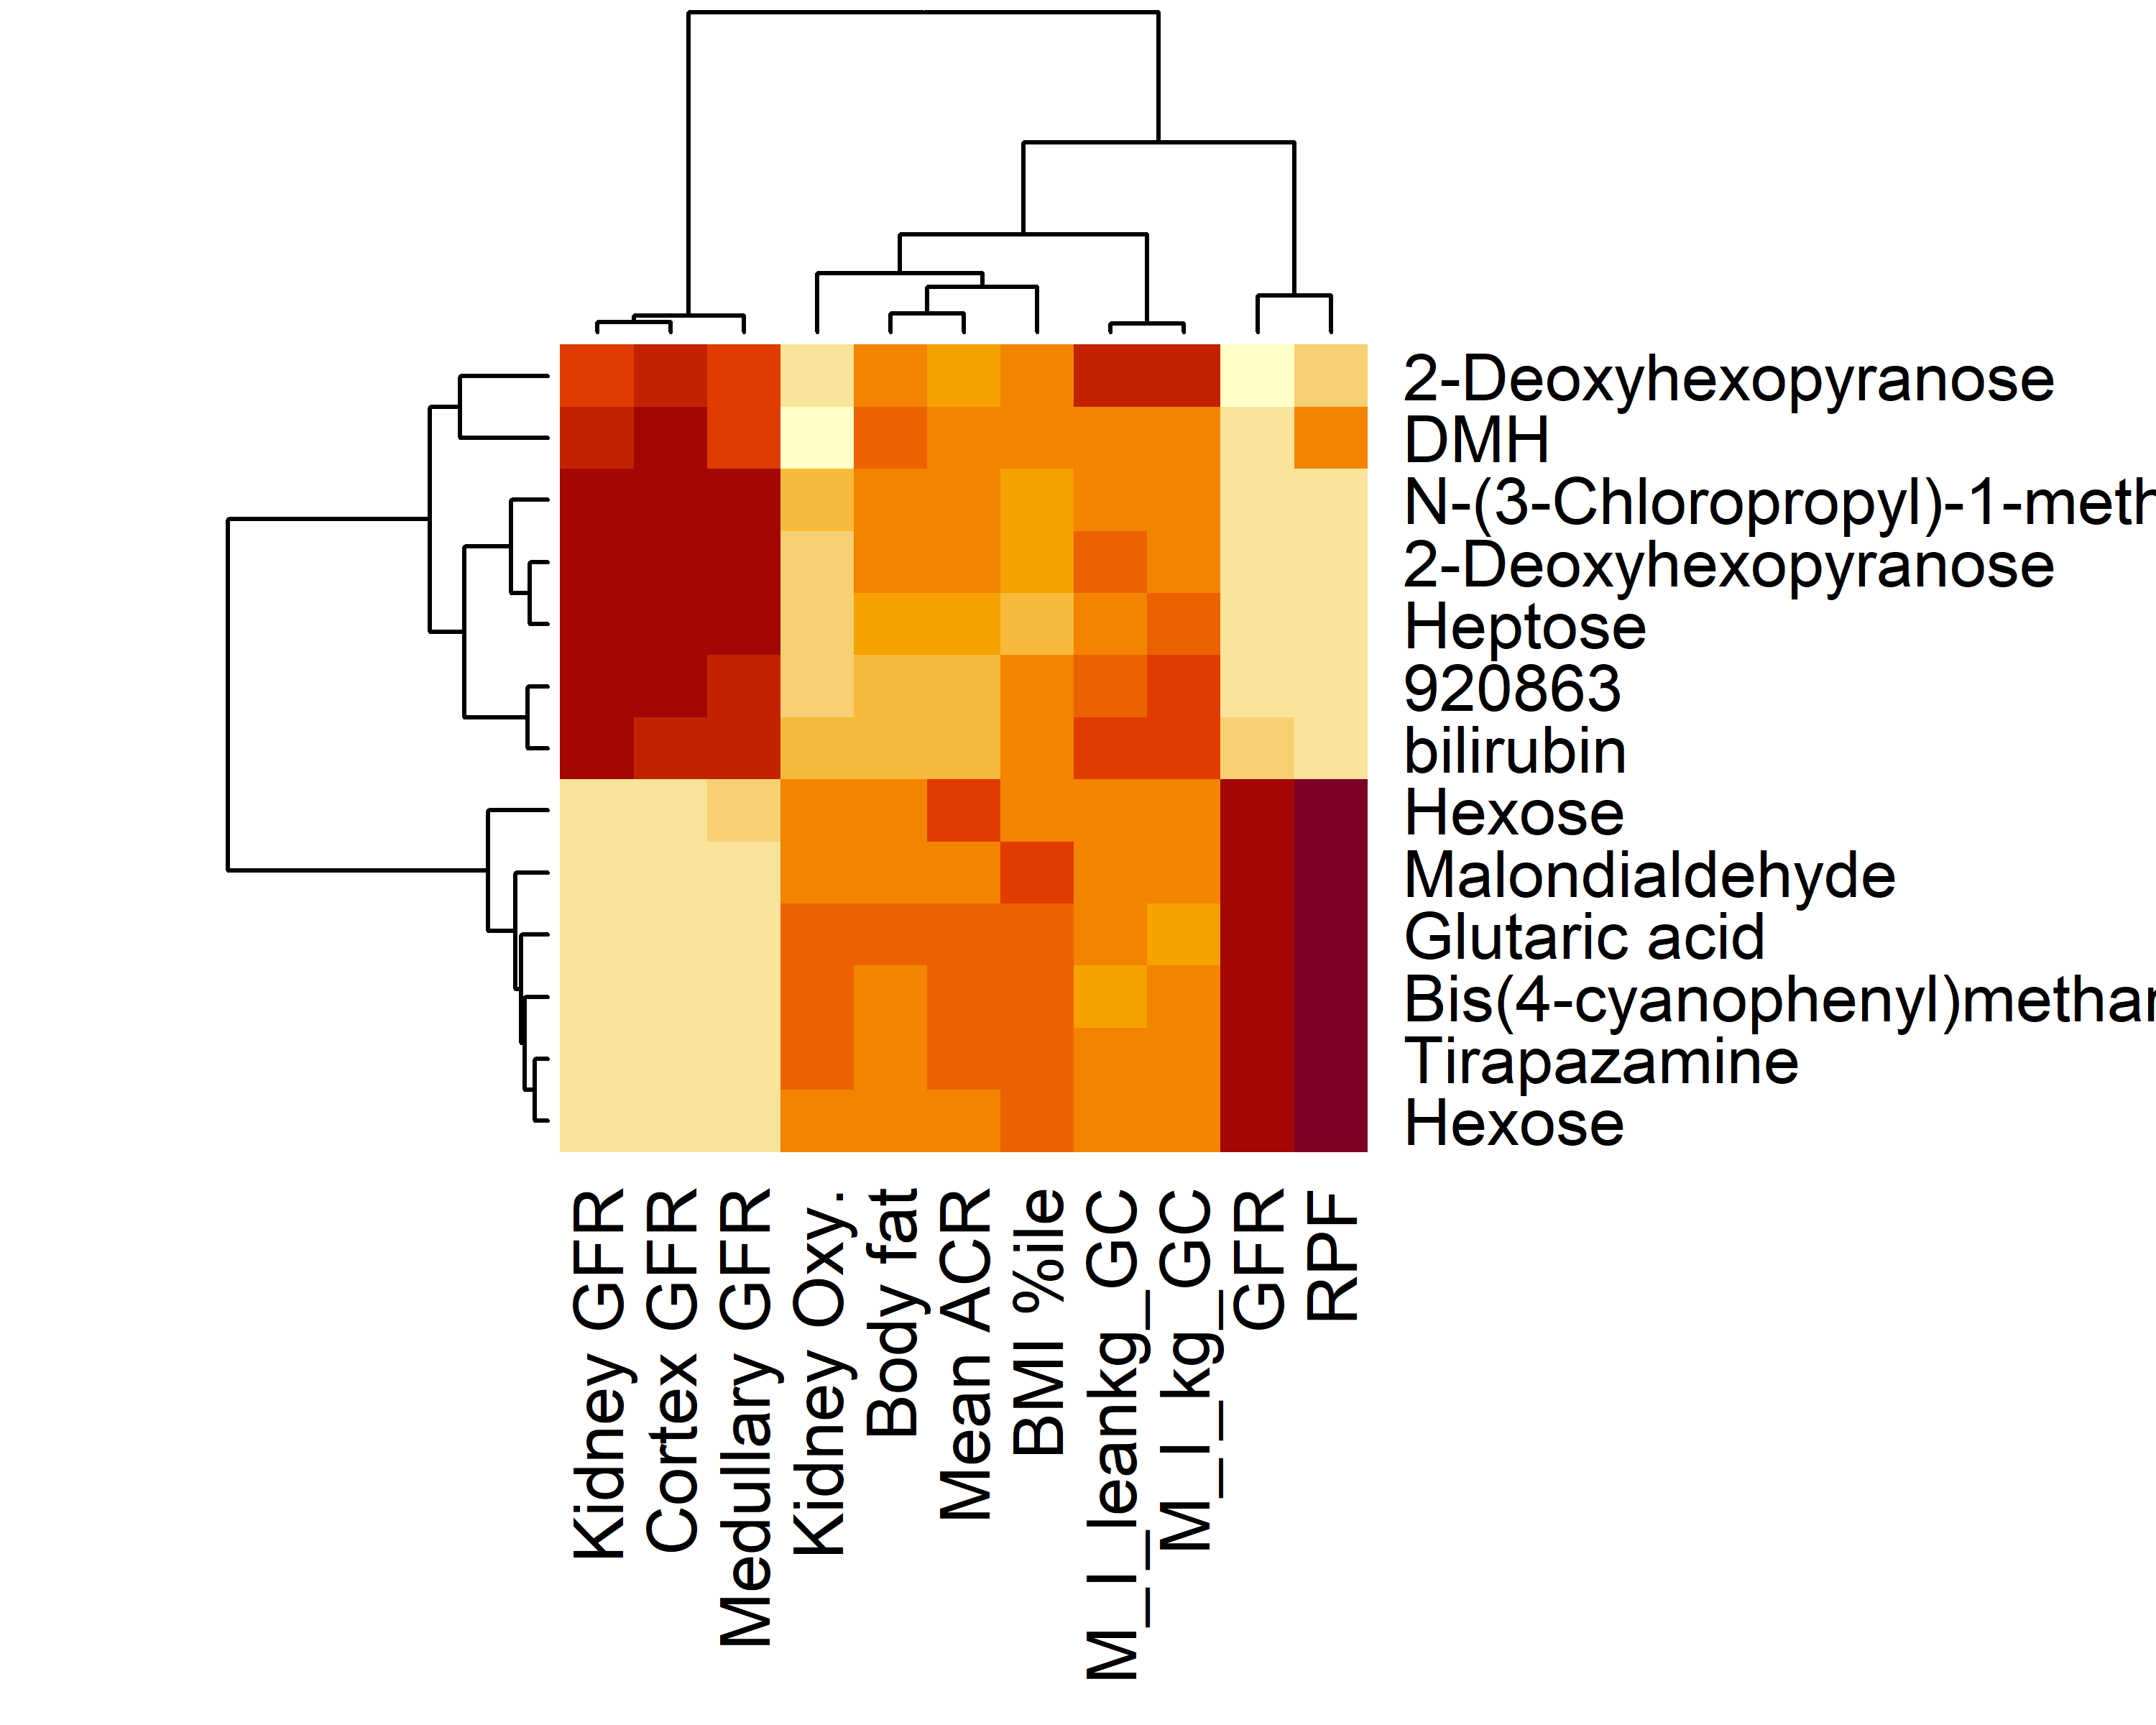

## Correlations by interesting metabolite

W_164.06781_0.827

|  |  |  |
| --- | --- | --- |
|  | R | p |
| RPF | -0.4905151 | 0.0211727 |
| GFR | -0.5127025 | 0.0007393 |
| Kidney GFR | 0.4317288 | 0.0255856 |
| Medullary GFR | 0.4062477 | 0.0554423 |
| Cortex GFR | 0.4374132 | 0.0189918 |

W_210.0733_0.808

|  |  |  |
| --- | --- | --- |
|  | R | p |
| GFR | -0.5008923 | 0.0012617 |
| Kidney GFR | 0.4349353 | 0.0229162 |
| Cortex GFR | 0.4431860 | 0.0153354 |

W_218.05484_0.783

|  |  |  |
| --- | --- | --- |
|  | R | p |
| RPF | -0.5013204 | 0.0148509 |
| GFR | -0.5210309 | 0.0004999 |
| Kidney GFR | 0.5116235 | 0.0010458 |
| Medullary GFR | 0.4658385 | 0.0063687 |
| Cortex GFR | 0.4963829 | 0.0017419 |

W_132.0409_0.774

|  |  |  |
| --- | --- | --- |
|  | R | p |
| RPF | 0.5659913 | 0.0012617 |
| GFR | 0.5175141 | 0.0005913 |
| Kidney GFR | -0.6112532 | 0.0000044 |
| Medullary GFR | -0.5407746 | 0.0002192 |
| Cortex GFR | -0.5974059 | 0.0000085 |

W_178.04699_0.769

|  |  |  |
| --- | --- | --- |
|  | R | p |
| RPF | 0.5738534 | 0.0009024 |
| GFR | 0.4818560 | 0.0028633 |
| Kidney GFR | -0.5617437 | 0.0000865 |
| Medullary GFR | -0.4986116 | 0.0015848 |
| Cortex GFR | -0.5344172 | 0.0003035 |

W_72.01995_0.772

|  |  |  |
| --- | --- | --- |
|  | R | p |
| RPF | 0.5147062 | 0.0091719 |
| GFR | 0.4191483 | 0.0322667 |
| Kidney GFR | -0.5045998 | 0.0014203 |
| Medullary GFR | -0.4589331 | 0.0083993 |
| Cortex GFR | -0.4773475 | 0.0039373 |

W_180.0627_0.77

|  |  |  |
| --- | --- | --- |
|  | R | p |
| RPF | 0.5920371 | 0.0004049 |
| GFR | 0.4813311 | 0.0029063 |
| Kidney GFR | -0.5681185 | 0.0000613 |
| Medullary GFR | -0.5157472 | 0.0007420 |
| Cortex GFR | -0.5494337 | 0.0001398 |

W_234.08169_0.827

|  |  |  |
| --- | --- | --- |
|  | R | p |
| RPF | 0.6256224 | 0.0000766 |
| GFR | 0.4881198 | 0.0021784 |
| Kidney GFR | -0.5518953 | 0.0001465 |
| Medullary GFR | -0.4998539 | 0.0015084 |
| Cortex GFR | -0.5208257 | 0.0005913 |

W_180.06231_3.886

|  |  |  |
| --- | --- | --- |
|  | R | p |
| RPF | 0.4814837 | 0.0280611 |
| Kidney GFR | -0.4143223 | 0.0466075 |